**Assignment : 4**

1. **Create Angular Application**

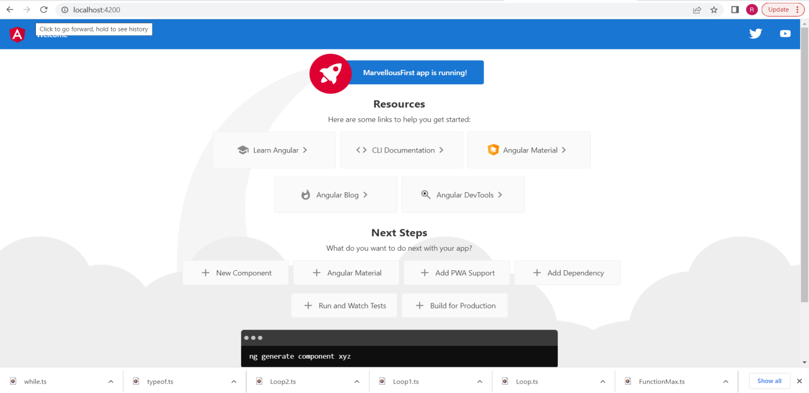

1. **Angular Application Which will display**

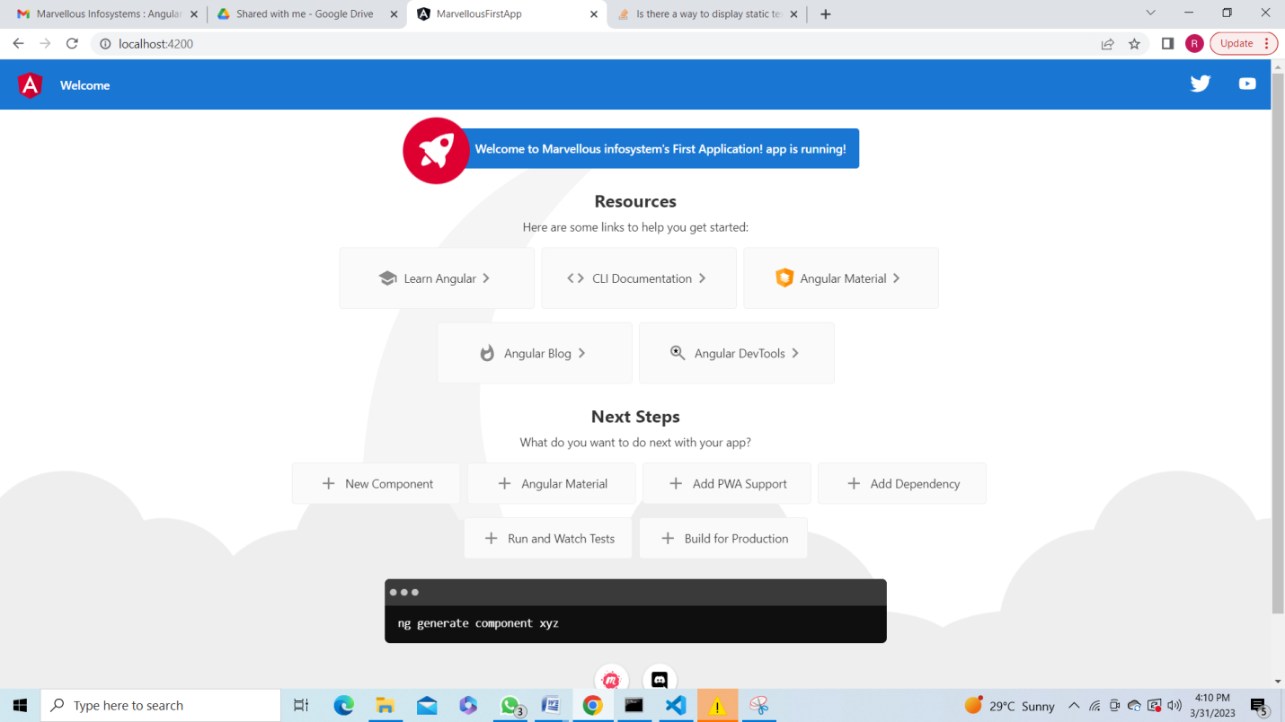

1. **Display one text field and one static text “Marvellous Infosystems”**

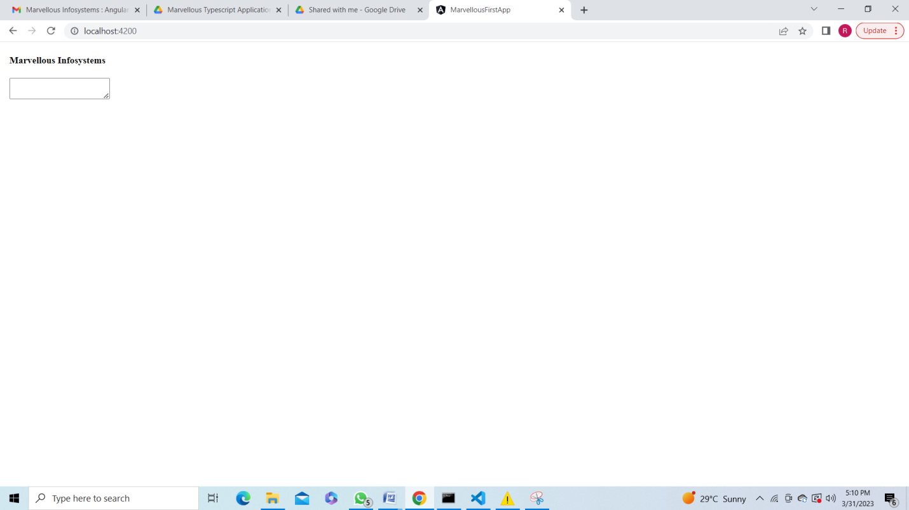

1. **Create one custom component named as Demo and render that demo component to app component**

